|  |
| --- |
| **Name: Vishnu Sadasivan**  **Roll No: 52**  **Batch: B**  **Date: 03-06-2022** |

**ADVANCED DATABASE MANAGAMENT SYSTEM LAB**

**Experiment No.: 9**

# Aim

To create database in MongoDB & practice its CRUD operations.

**Procedure:**

1. Display available Databases and selecting the desired database.

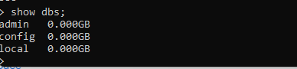

1. Creating collection in the database.



1. Insertion of fields

* + 1. Insert: Inserts entered queried documents into the collection.

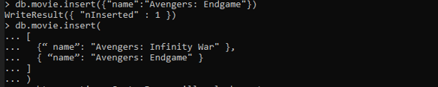

* + 1. InsertMany: Inserts multiple documents into the collection at same time.

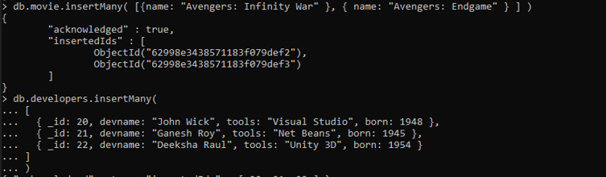

1. Find fields and documents using filters

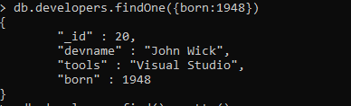

1. Update fields according to the filter query conditions
   * 1. UpdateOne: Updates only one document.

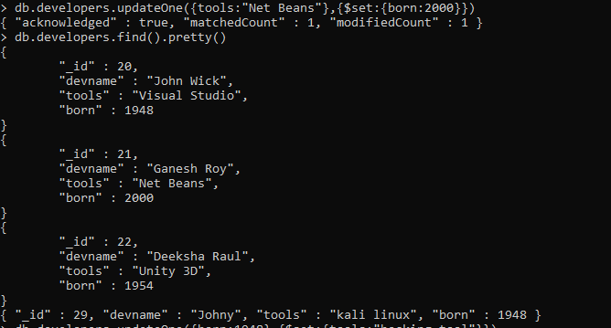

* + 1. UpdateMany: Updates multiple documents according to the query from the collection.



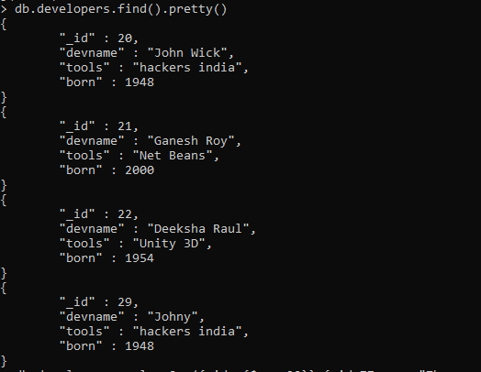

* + 1. replaceOne: Replace the whole specified document with the new values.

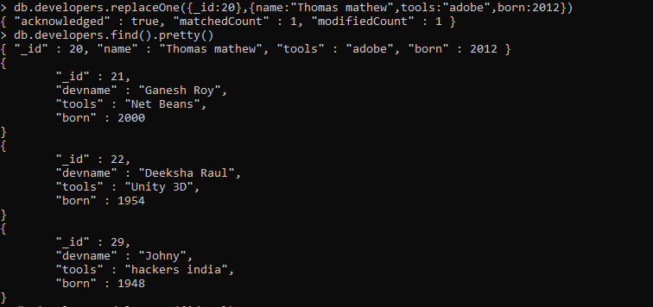

1. Delete documents according to specified conditions.
   1. DeleteOne: Deletes only one documents according to the condition.

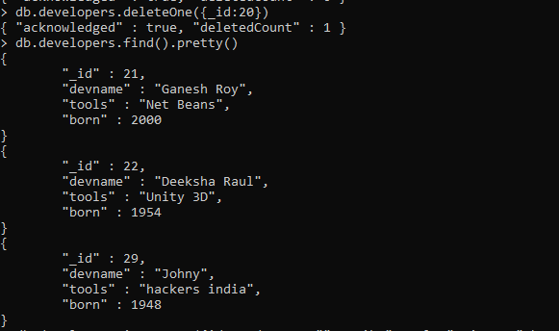

* 1. DeleteMany: Deletes all the documents that satisfies the condition.

